WHITSUNDAY MOTOSPORTS CLUB
GRAND TRACK OPENING

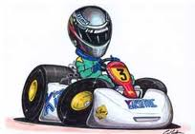

SUNDAY 4TH DECEMBER – 10.00AM

After 6 years of plotting, planning, scheming and loads of hard work by a handful of Club members, the BIG DAY finally arrives. Come on out to Lascelles Road (Proserpine Airport) and check out the brand new facility and see some real Race Bikes, Karts and Exotic Cars on the track! Food and soft drinks available at the venue. FREE ENTRY!

10.00am Gates open and track walk available – static display of race bikes, karts and some great cars.

1.00pm Official Opening Ceremony.

1.30pm FIRST EVER LAP BY WORLD FAMOUS BIKE CHAMPION

2.00pm Demonstration laps, Bikes, Karts and Exotic Cars*

4.00pm Track activity ends – social hour!

For more information call Club President....Andrew Auld 0429 875729
or....James Dwight 0402 809197

*Please note that for insurance reasons ‘Demonstration Laps’ are by invitation only and are not open to the General Public.

